TASK 8 – Apply Polymorphism
Student Name: B. Muni Chandini
Register Number: 192524283

1. Compile-time Polymorphism (Method Overloading)
Two versions of calculateFee exist:
Java
public double calculateFee(int minutes)
public double calculateFee(int entryHour, int exitHour)
- The compiler decides which method to call based on the number and type of arguments.
- This is resolved at compile time.
2. Runtime Polymorphism (Dynamic Method Dispatch)
- We create an array of Vehicle references:
Java
Vehicle[] parked = { new TwoWheeler(...), new Car(...), new ElectricCar(...) };
- This is upcasting (subclass object stored in superclass reference).
- When we call v.calculateFee(180), the JVM looks at the actual object type at runtime and calls the correct ratePerHour() method.
- This is called Dynamic Method Dispatch.
3. Trace of one call
Step | Declared Type | Actual Object Type | Method Executed
1 | Vehicle v | ElectricCar | calculateFee(180)
2 | - | ElectricCar | ratePerHour() → returns 30
3 | - | ElectricCar | chargingFee(10) → 120
Final fee |  |  | 90 + 120 = 210
4. Why this design is better
- No long if-else or switch chains that check vehicle type.
- Adding a new vehicle type does not require changing the loop.
- Code is cleaner and follows the Open-Closed Principle.
5. Alternative Concept and Complexity Analysis
Current Design: Dynamic method dispatch
Alternative: Using instanceof checks and casting for every vehicle type.
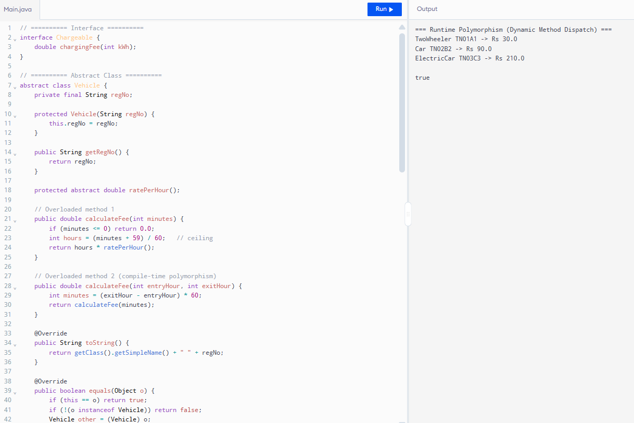
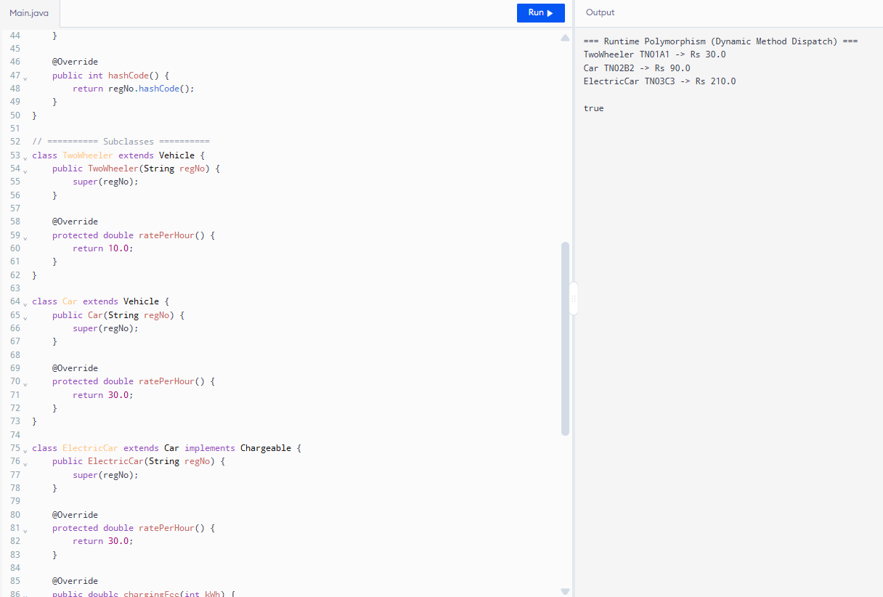

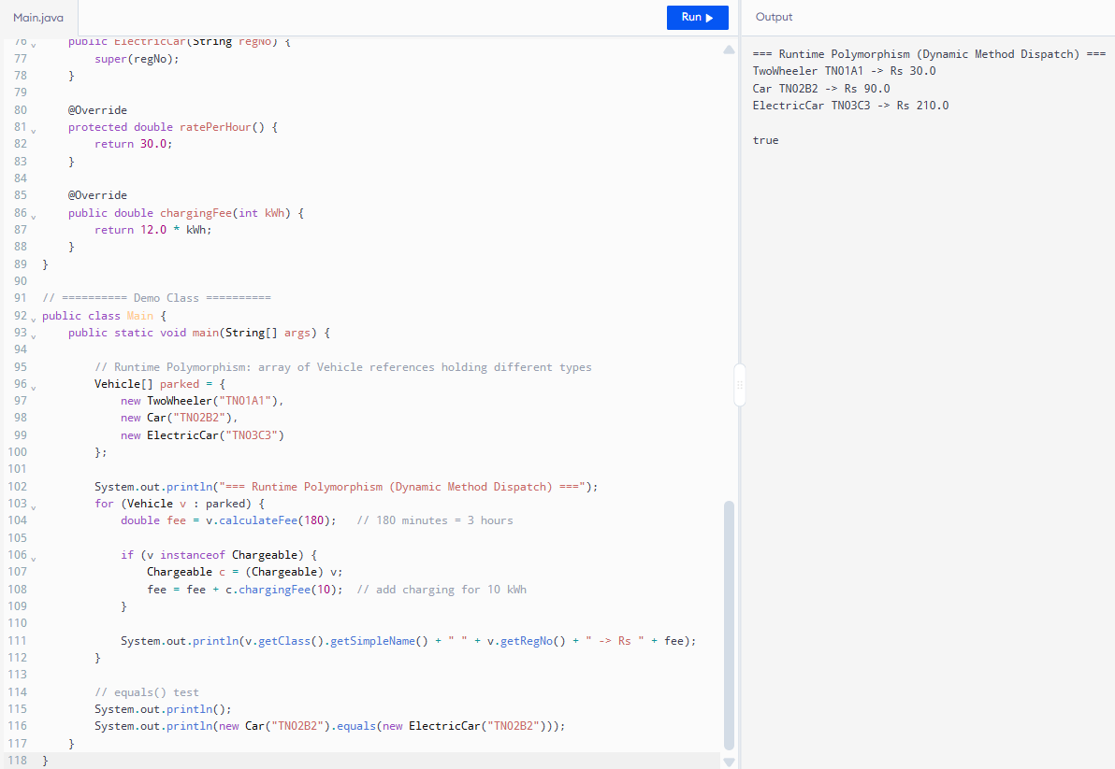
Aspect | Dynamic Dispatch (my design) | instanceof + casting
Time per call | O(1) | O(k) where k = number of types
Adding new vehicle type | No change in existing code | Must add new if-condition
Code size & maintenance | Small | Grows with every new type
Conclusion:
Dynamic method dispatch is faster and much easier to maintain when the number of vehicle types grows.

